CURRICULUM VITAE
1 Personal Information
Name | Li Long / 20 Jan 1982 / Chinese
Professional Focus | Project Quality Management / Welding & Piping Quality Supervision / NDT Management
Certifications | PMP / PRINCE2® Practitioner / CWI (Certified Welding Inspector) / ASNT Level II (RT & PT)
Education | Bachelor, Liaoning Petrochemical University
Computer Level | Microsoft office; Power Point; CAD;
Email / Phone | li1982long@163.com / +8618677337727

2 Core Quality Competencies
- Competent in end-to-end project quality management system establishment, implementation, maintenance and continuous improvement for oil & gas projects..
- Experienced in QA/QC team leadership, supervision, performance management and cross-departmental coordination throughout engineering, procurement, construction and commissioning phases.
- Expert in full-cycle welding quality management including WPS/PQR review, welder qualification, welding process surveillance and weld quality control in compliance with AWS, ASME and API codes.
- Competent in NDT management covering RT/PT testing planning, implementation supervision, report review and quality assurance of inspection activities.
- Familiar with piping/pipeline quality standards, construction quality control, inspection protocols and handover documentation requirements.
- Over 16 years of quality management & supervision experience in international oil & gas projects (Iraq, Malaysia, Sudan, etc.), with strong cross-cultural communication and problem-solving capabilities.

3 Work / Project Experience
2023-03 to 2025-12 / Company: Long River Middle East Consultant DWC-LLC
Project: PMC, Majnoon oil field, Iraq owned by Anton Oil under BOC
Position: Piping Quality Engineer & Project Quality Supervisor
Responsibility:
Conduct quality review of piping design documents, drawings, material specifications and construction procedures to ensure compliance with project standards and codes.
Perform on-site quality inspection and surveillance for piping fabrication, installation, welding and testing; identify and track non-conformities until closure.
Supervise project quality progress, coordinate quality issues between client, contractor and PMC team, and organize quality coordination meetings.
Ensure quality deliverables, inspection records and handover documents are complete, accurate and traceable throughout project execution.

2019-02 to 2023-02 / Company: CNOOC Safety Technology Service Co., Ltd
Project: General Services for new Projects PMC, Missan oil field, Iraq owned by MOC CMIT
Position: Lead QA/QC Engineer (PMC)
Responsibility:
Led the QA/QC team for overall quality management, including work assignment, personnel supervision, performance monitoring and cross-party coordination.
Developed and maintained project quality management system, including quality procedures, inspection & test plans (ITP), and quality documentation control.
Reviewed contractor-submitted quality procedures, WPS, NDT plans and inspection records; participated in critical inspections, witness tests and project acceptance.
Conducted on-site quality surveillance for welding, NDT, piping and construction activities; analyzed quality data to drive continuous improvement.
Organized quality meetings, prepared quality status reports, and implemented corrective & preventive actions to reduce non-conformities.

2016-12 to 2019-01 / Company: HuanQiu Project Management (Beijing) Co. Ltd.
Project: MULTI-PRODUCT PIPELINE PROJECT, Malaysia, owned by Strategic Energy Resources Sdn Bhd (SSER)
Position: Construction Lead Engineer (PMC)
Responsibility:
Engaged in project planning, ensuring the plan adherence to required milestones and timelines.
Preparation of construction management plans and procedures, review related documents submitted by contractor.
Site management to ensure the construction activities comply with safety and quality requirements.
Coordination and communication with relevant parties for problem solving encountered related to construction.
Supervision for general construction activities & progress, reporting for construction events and joining related meetings.

2011-10 to 2015-05 / Company: China HuanQiu Contracting & Engineering Corp.
Project: NDT Service Contract in Rumaila oil field (2014-06 to 2015-05) owned by BP Iraq N.V./Rumaila Operating Organization
Position: Project Manager
Responsibility:
Management of all aspects of project execution. Mainly including project planning, technical coordination, equipment/apparatus and consumables procurement managing, task instruction, internal and external reporting and meetings with relevant parties, as well as other issues supervision and coordination.
Project: GEC Project in Rumaila oil field in Iraq (2011-10 to 2014-04) owned by BP Iraq N.V./Rumaila Operating Organization
Position: Pipeline / Piping engineer
Responsibility:
Design the pipeline / piping system according to the codes & project requirements. Design documents such as drawings and MTOs preparation.
Conduct site survey for preparation of the pipeline route and locations of related facilities.
Communicate with other disciplines for necessary information, ensure the reasonability of the technical proposal.
Providing design inputs data / conditions for the downstream discipline.
Providing technical support to construction, operation and maintenance personnel.

2007-08 to 2011-08 / Company: China petroleum 6th construction company
Project 1: Alternation project for 5 million ton per year refinery in Hohhot (2010-09 to 2011-08) owned by Hohhot petrochemical Co.
Project 2: Tank expansion project in FULA, Sudan (2009-02 to 2010-06) owned by Greater Nile Petroleum Operating Company
Project 3: Maintenance of facilities in HEGLIG oil field in Sudan (2008-08 to 2009-02) owned by Greater Nile Petroleum Operating Company
Project 4: GUMRY FPF project in Sudan (2008-02 to 2008-08) owned by Petrodar Petrol Operation Company
Project 5: Tank expansion project in FULA, Sudan (2007-12 to 2008-02) owned by Greater Nile Petroleum Operating Company
Position: Welding and quality engineer & supervisor
Responsibility:
Oversaw full-process welding quality control, including WPS development, welder qualification, process surveillance and defect rectification.
Implemented quality monitoring in accordance with project specifications, contract requirements and industry codes (piping, structural, pressure vessel).
Conducted regular on-site quality inspections, tracked non-conformities and ensured timely closure.
Managed welding quality database, inspection reports and quality records to maintain full traceability.
Reported quality status and NDT results in daily meetings to support production quality control.

Attachments
1, PMP Certificate | 2, PRINCE2-Practitioner Certificate
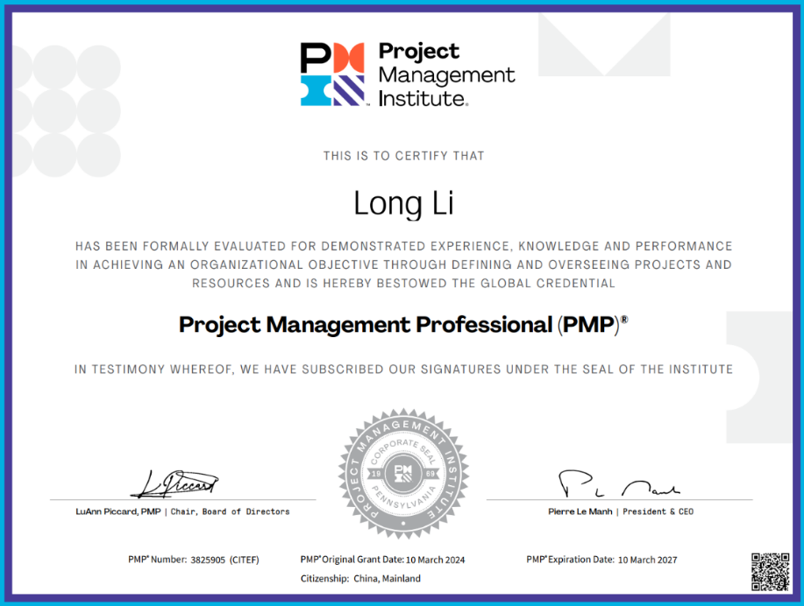 | 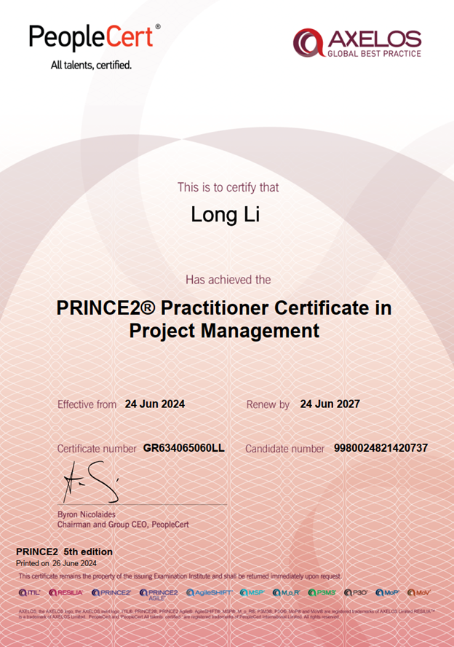
3, CWI Certificate
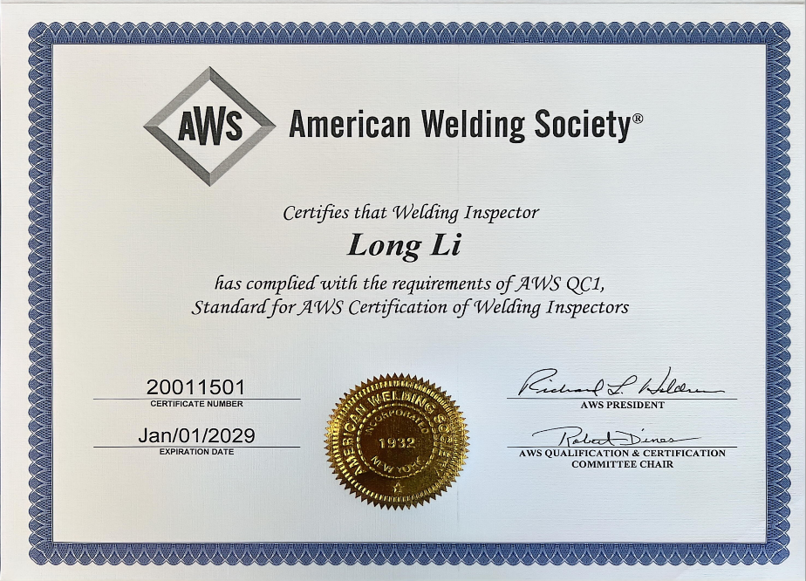
4, NDT Certificates
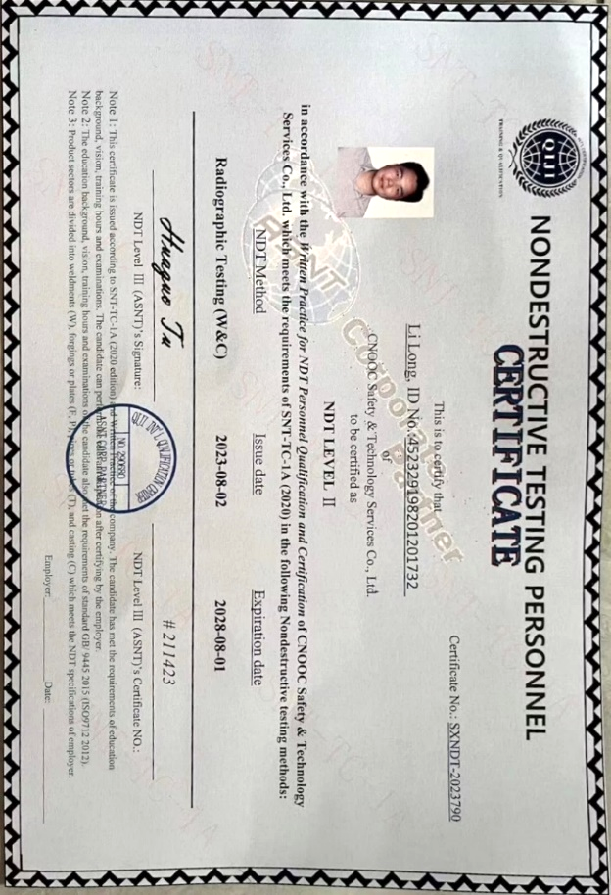 | 